Using Postman, I was able to test my API:

# Roadblocks

One issue I ran into when setting up my Unit Test project was that Visual Studio was unable to set up a project reference, displaying the following error:

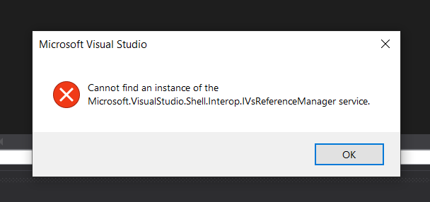

Unsure what this meant, I looked up the error message typing it word for word into my search engine. After digging around, I found an article that detailed the steps to add the missing dll. I opened a developer command prompt and ran the following command:

*gacutil -i Microsoft.VisualStudio.Shell.Interop.11.0.dll*

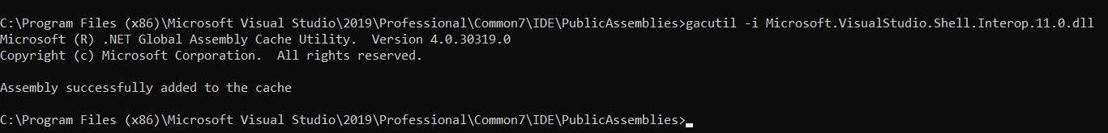

I then restarted visual studio and tried again and I was able to add the project reference.

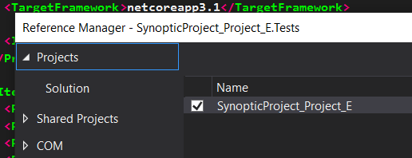

# Setting up Continuous Integration

# Creating documentation with Sandcastle